Academic Banquet

Tuesday, June 29, 2008
7:00pm

We request the honor of your presence at our

Annual Academic Banquet.

This banquet is in honor of those
students that have achieved scholastic merit during the
2006-2007 school year.

This is a special

celebration in which presentations will
be made and dinner will be served.

Formal attire is required.

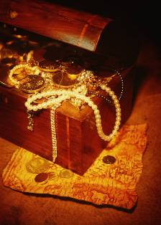
Matthew 13:46
“The Kingdom of Heaven is like unto a merchant man, seeking goodly pearls: Who, when he had found one pearl of great price, went and sold all that he had, and bought it.”

